Example-01: How to set up a C# project in Microsoft Visual Studio
- Open “Visual Studio 2022” application on your computer (from MS-Windows Start Menu). It will display “Visual Studio 2022” dialog box.
- Click “Create a new Project”, last item in right column of the dialog box.
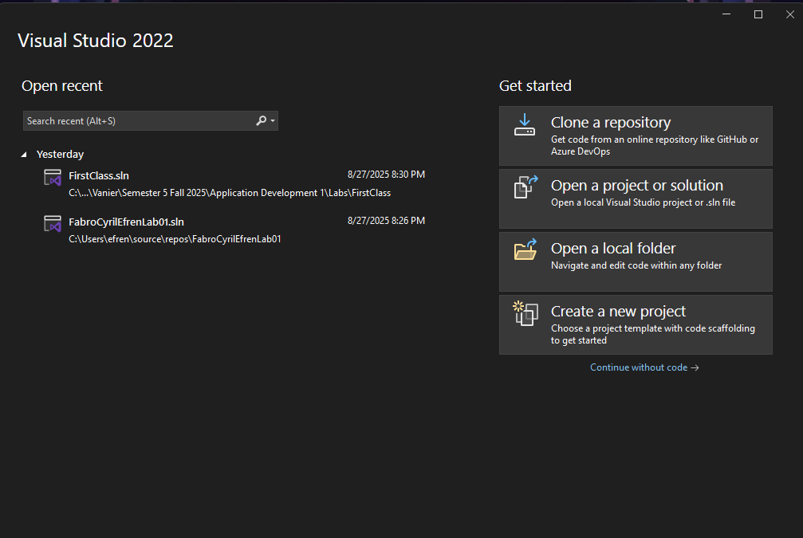

3. In the following “Create a New Project” dialog box, select:
a) “C#” in the first “Drop-down list”,
b) “Windows” in the second “Drop-down list”, and
c) “Console” in the third “Drop-down list”, then
d) Click on the “Console App (.NET Framework)” in right column of the dialog box to select it, as shown below:
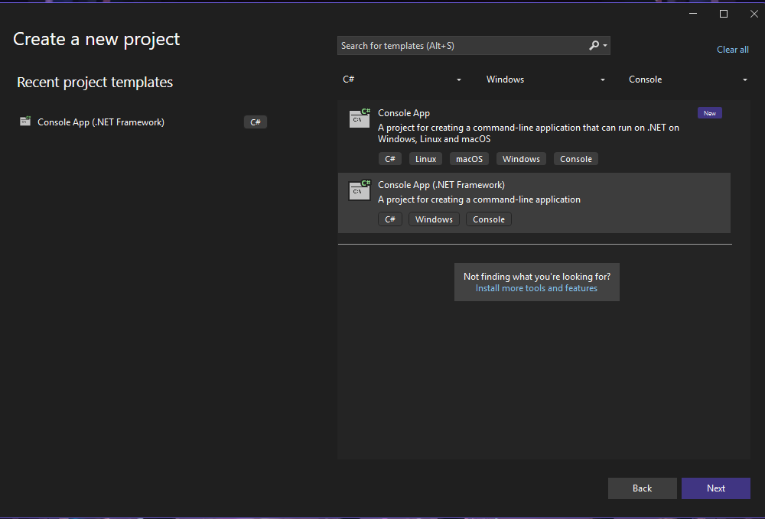

5. In the following dialog box “Configure your new project”:
- In the “Project name” box, type “FirstClass”,
- Click “Browse” button on the right side of the “Location” box to browse your hard disk or memory stick folder/directory, to select a folder/directory where you will save programs for this course.
- iii) Make sure that the folder/directory name in the “Location” box matches the folder/directory, where you want your stuff stored.
6. Click the “Create” button, in the lower right corner of the dialog box.
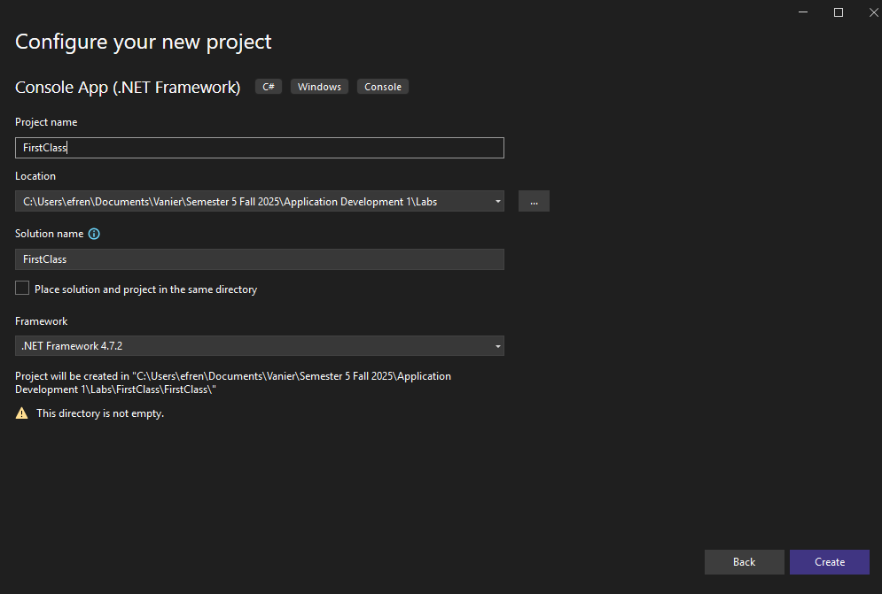

7. Now you should have a “MS-Visual Studio IDE” window, showing a small C# program in skeleton form ready for you to modify in the editor. See sample window below.
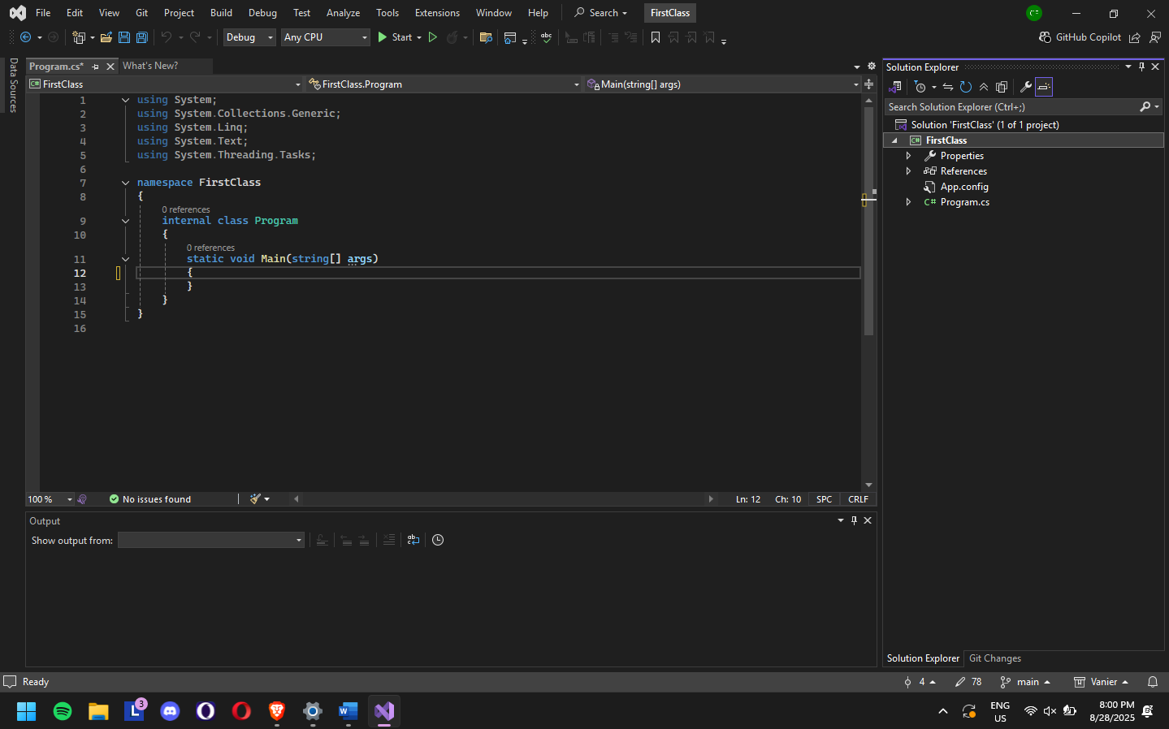

8. Modify this skeleton program by modifying one line inside the static void Main() method to: Console.WriteLine("This is my first C# Program");
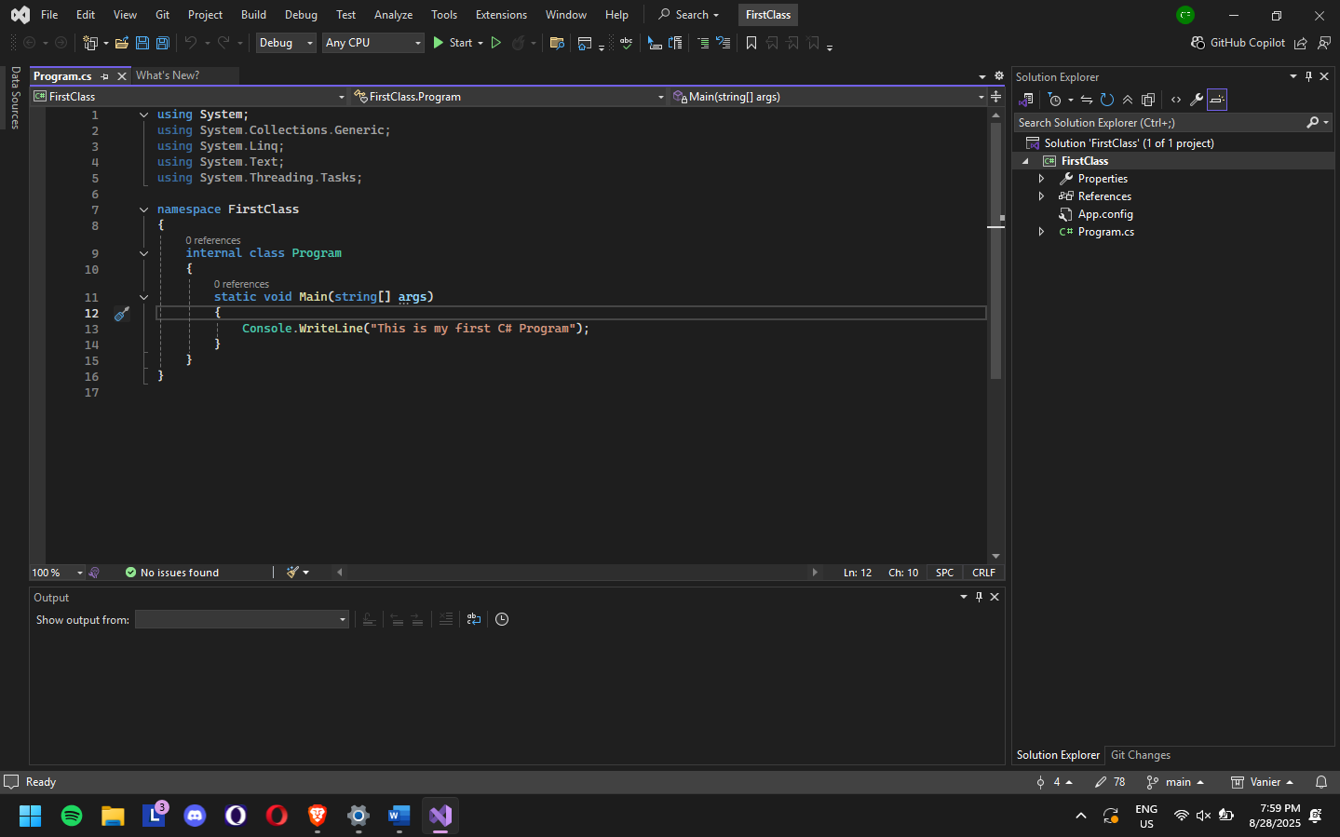

9. Let’s Compile and execute this C# beginner program.
a. Click Build → Build Solution to compile the program.
b. Alternatively, click Debug → Start Without Debugging to execute the program.
c. If the program contains any syntax or compile-time error, they will be listed in the “Error List” window, at the bottom of the “MS-Visual Studio IDE” window.
d. If the program contains no compile-time errors, this will compile your program and build it into an executable file (named FirstClass.exe, in one of the project’s subdirectories).
e. To execute the program, press CTRL + F5 keys on keyboard, which invoke the Main method.
f. You see a standard text command-line window (as shown below) with the "This is my first C# Program!" message and another message to press any key to continue.
g. Close this text command-line window by pressing any key
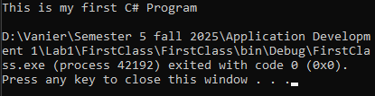
10. Now we will purposely introduce an error.
a. Go to the end of Console.WriteLine("This is my first C# Program"); and remove the semi-colon.
b. Notice that an error immediately shows at the bottom in the “Error List” panel.
c. Double-click on the error message and the problem is highlighted in the program, and insertion point will jump to error position.
d. Try to run the solution with “Debug” → “Start Without Debugging”. It fails with an Error Dialog Box. Click “No” to close the Dialog box.
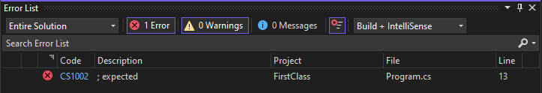
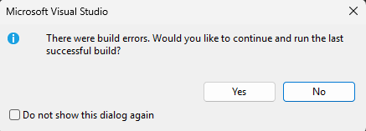
11. Fix the error and run your program again.
12. Click File → Save All to save the Project.
13. Click File → Close SoluƟon to close the Project.

Example 2: Performing Arithmetic Operation
1. In “MS-Visual Studio 2019” IDE, click File → New → Project… to display the “Create a New Project” dialog.
2. Now create a new project “ArithmeticOperations”, by following the steps 1-6 shown above in Example-01.
3. Type the following code into your new program skeleton.
3. Save the file, compile the program, and execute it. The output should look like as shown below:
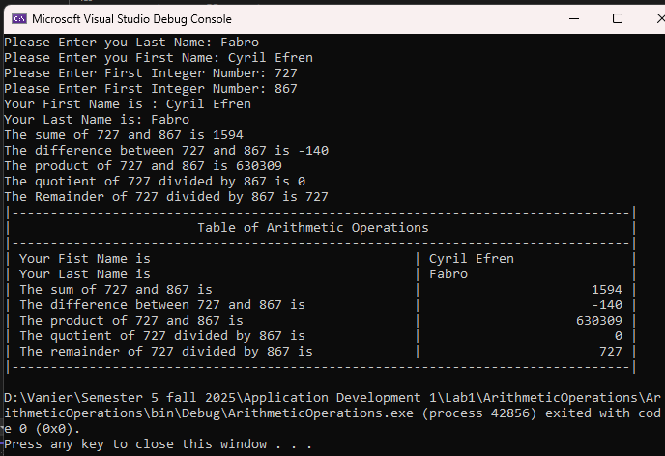
- Execute the program again with different input values. The output should look like as shown below:

5. Repeat this process several times. After each execution, analyze the output to make sure you understand the results of the arithmetic operations.
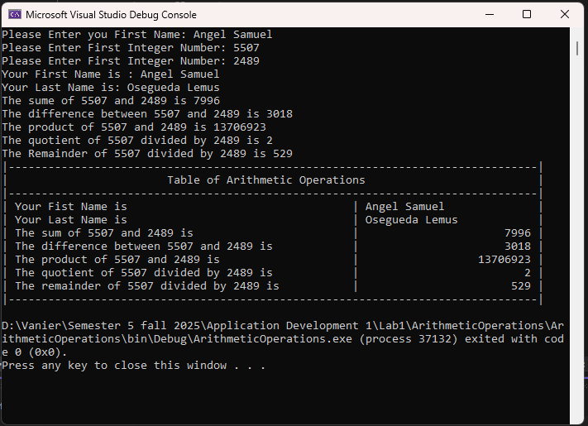
As an experiment, try commenting out the four using directives (at the top of the program after the using System;), one-by-one

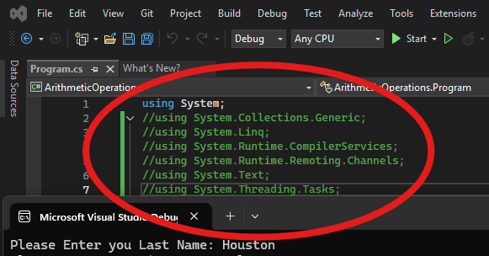

Example-03: Using the string data type
1. Now create a new project “CompareNames”, by following the steps shown above.
2. Type the following code into your new program skeleton.
3. Save the file, compile the program, and execute it. The output should look like as shown below:
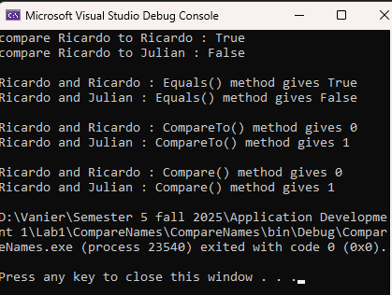
4. Save and close your project.

